THE CAST

DEQUANE
I love to play basketball and football each and every year. I couldn’t this year because I’m in here. When I’m at home I help my mom cook for Thanksgiving, for Christmas, and even on Sundays.

DOUGLAS
I was born and raised in Rochester. I love music.

GARRETT
I like to write books, and I like to help others. I want to better my life.

JERMAINE
I’m a black young man trying to survive.

JOHN
I can draw, plus I am very athletic and I can rap/sing a little.

JOSEPH
I like freedom. I like tattoos. I love life.

MONTREAL
I love to write.

There are a lot of questions with no answers.
I was born in Massachusetts, in Concord.
I grew up and was introduced to the streets.
Maybe it’s my fault or the government’s
or what they feed us or TV, or music.
Life is crazy.

Sometimes there’s a kind person who helps out.
I’m fed up.
Can I have one more chance at life, joy, adventure?
I feel like a nobody,
garbage thrown into a dumpster.
Please forgive me

Growing up I had lots of dreams. I wanted to be a lot of things,

but my dreams popped,
like a kid holding a balloon.

So many tears, I could have drowned like a kid that couldn't swim. I was always told I wasn't going to be anything, and I would die by the age nineteen because of how I lived.

There’s always someone
trying to turn the light out at the end of the tunnel.
I’m stuck like a stone in the basement,
lost in my own tracks,
no guidelines whatsoever.

Can someone help me? Or my spirit?

Four months of Hell, no sunlight. It feels like I’m in a dungeon getting fed like an animal. I wish I were home to smell the dirt, eat home food. I sit on my bunk thinking of what I could do. I’m tired or waking up realizing I’m in jail.

Sometimes
it makes me pour out tears
missing my family, friends, the outside world.

What brings one another down?
Hearts are broken all the time, why?
I wake up in the morning and every once in a while when I splash some water on my face,
the nightmares
make me nervous like a kid getting told about the boogieman under his bed
or on the first day at school not knowing anyone.

Montreal

RICKY
I like playing Basketball. I like clothes!

ZACHARY
I live off peace of mind.

The New York State Literary Center, Rochester City School District and the Monroe County Sheriff's Office

The New York State Literary Center
http://www.nyslc.org/
Dale Davis, Executive Director

Rochester City School District
http://www.rcsdk12.org/
Dr. Bolgen Vargas, Interim Superintendent
Margaret Porter, Program Administrator, Youth and Justice Program

Monroe County Sheriff’s Office
http://www.monroecounty.gov/sheriff-index.php
Patrick O’Flynn, Sheriff
Ronald Harling, Jail Superintendent
Edward Iganrri, Director of Rehabilitation

”Born and Raised In The Roc: Timeline 2011” is made possible with public funds from The New York State Council on The Arts, a State Agency.



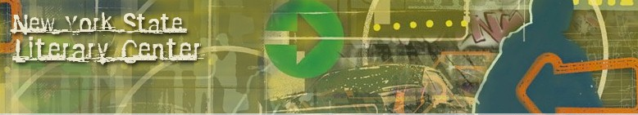

The New York State Literary Center, Rochester City School District and the Monroe County Sheriff's Office

BORN AND RAISED IN THE ROC: TIMELINE 2011

BY
Dale Davis

WITH
Branden, Paris, Dajon, Daniel, Danny, Dillon, Douglas, Jermaine, John, Josh, Kenneth, Lorenzo, Marcos, Montreal, Oshay, Shendale, Thomas, Trevor, and Zachary

DIRECTED BY
David Shakes

INTERN
Nia Itoh

PRODUCTION ASSISTANT
Mike Whann

BEATS and MUSIC
Tech Productions and Mansion Studios
Common, “A Dream”
Gil Scott-Heron, “The Revolution Will Not Be Televised”

DJ
Douglas

